Arch bridges are simple but strong. It is made with two anchor points and a platform in the shape of an arch connecting the two anchors.Arch bridges are quite old but still used today. Many arch bridges are made of stone or brick. You will find arch bridges in many state and national parks in the us. 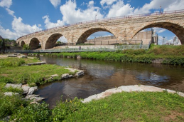
The Stone Arch Bridge is a key link in the St. Anthony Falls Heritage Trail, which has walkways and bicycle lanes. The Heritage Trail is a two-mile trail with an extensive system of interpretive and directional signs .The Stone Arch Bridge is the only bridge of its kind over the Mississippi River. It is made of granite and limestone, and measures 2100-feet long by 28-feet wide. The bridge consists of 23 arches, and spans the river below St. Anthony Falls in Minneapolis, MN.
What are the pros and cons of making an arch bridge? Arch bridges are very strong for how simple they are.They are considered beautiful and can be made from a wide range of materials from stone to steel.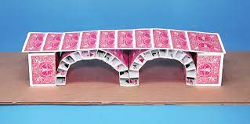
I will tell you how to make a card bridge like the one shown above. First take ten cards and lay them down next to each otherthen tape them this be your roadway. Next take 8 cards and fold them in half then line 2 of them up together in a square shape, tape it and do the process 3 more times. Now take 26 cards take 4 cards then fold the card into 4 ths fold them into squares then tape them. Now take the other 22 and fold them into fourths then cut ⅛ of the card after that make them into trapezoids.

